So basically this task has 2 parts, part 1 is about KPI which i will check later; and part 2 is writing mdx queries for our analytical problems defined in the requirement specification but i recommend checking project report2 coz we listed all updated queries in this file and it contains info about the cube which is somewhat help when writing queries.

First we need to connect to the analysis service in ssms and then add new queries, the screen should look like this:
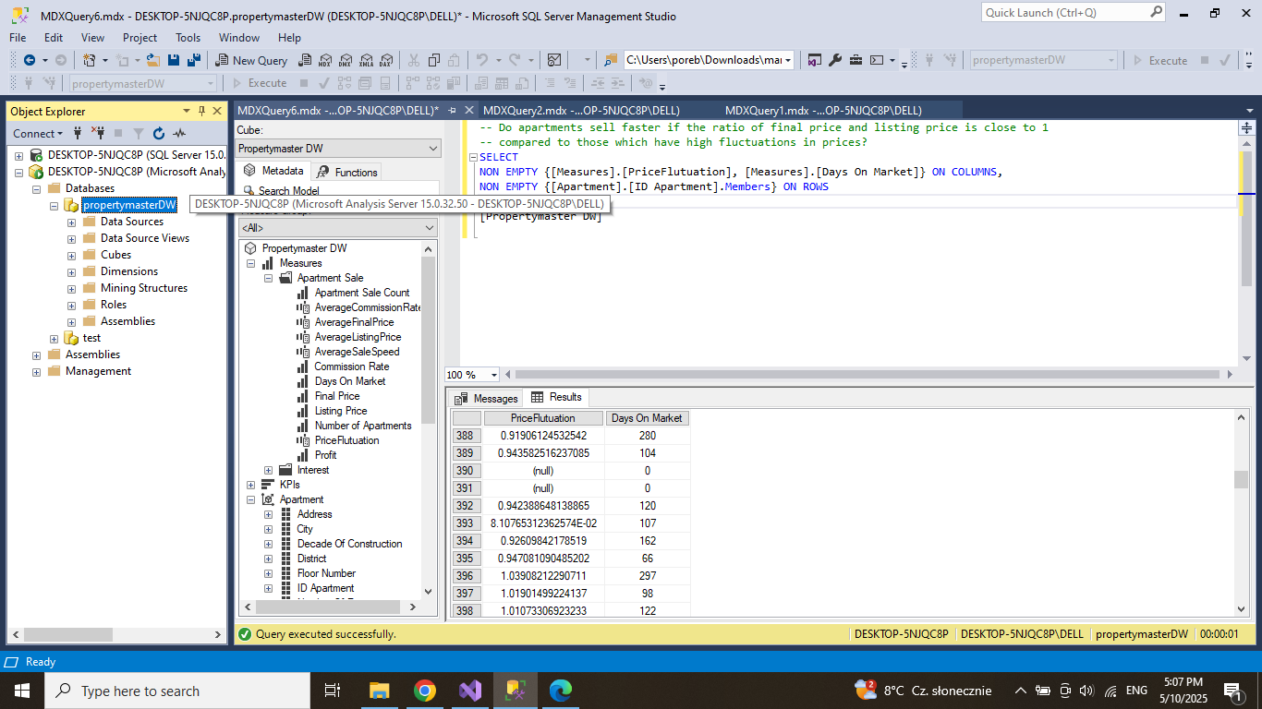

I’m writing queries for the first 5 questions but i ran into some problems:

Query 1: The row names are not shown for each apartment attribute but chatgpt said that it’s a common display issue so i left the query as it is but feel free to modify it if you have a better idea ;) i see the same problem for me so i think this should be fine, i think its a display error but not ours
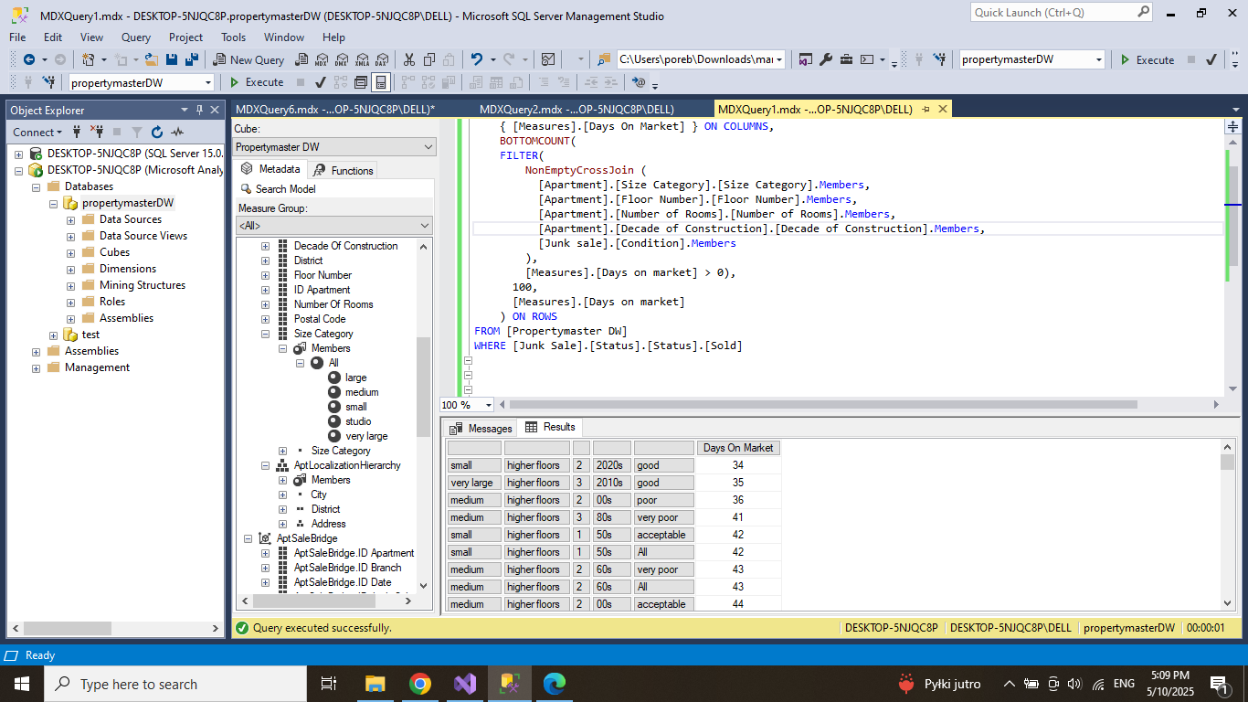
Query 3: when i query the price fluctuation there’s some invalid number like “-nan(ind)” which is caused by dividing 0s, so i changed the expression in visual studio as shown below:
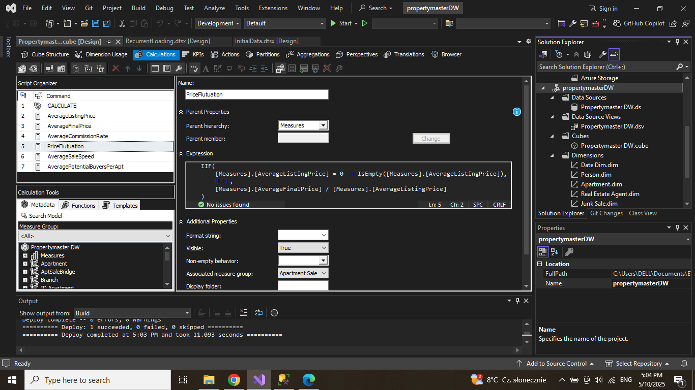
You can do the same on your laptop:
IIF(
[Measures].[AverageListingPrice] = 0 OR IsEmpty([Measures].[AverageListingPrice]),
NULL,
[Measures].[AverageFinalPrice] / [Measures].[AverageListingPrice]
)

This way the invalid value will be shown as null
Then reprocess the cube, refresh the data warehouse in ssms, and it should work thanks for letting me know :)))) i changed it and it looks fine
Query4: I have 2 queries wrote for question 4 but none of them is perfect coz there is no group by function in mdx…. Yeah i get what you mean… i think what you have done for version 2 is fine? Idk we can try to figure it out later if we have time

Query 6 : so basically this works, but the problem is the query is about branches and districts, so i would have to connect the city of branch with the city of apartment and then extract districts from apartment, the problem is when i do that the number of potential buyers everywhere is null… so the query that works uses only the apartment dimension, i tried to include the branch dimension (commented query) but nothing works…. I even tried to execute this query in the browser like drag cities for branch and districts from apartment and then the number of potential buyers was not null so im not sure what is wrong in sql yeah i think this works and we can do this without branch coz branch city is the apartment city (maybe they are linked somehow in the cube so we don’t need to set branch city explicitly?) and i also checked in the browser and the result is correct.
One problem is i can see the same district under same city twice, one is all one is with city name, so i suggest we modify the query to get rid of all by changing Members to Children (i uploaded query 6_v2 file with the change)
Before:
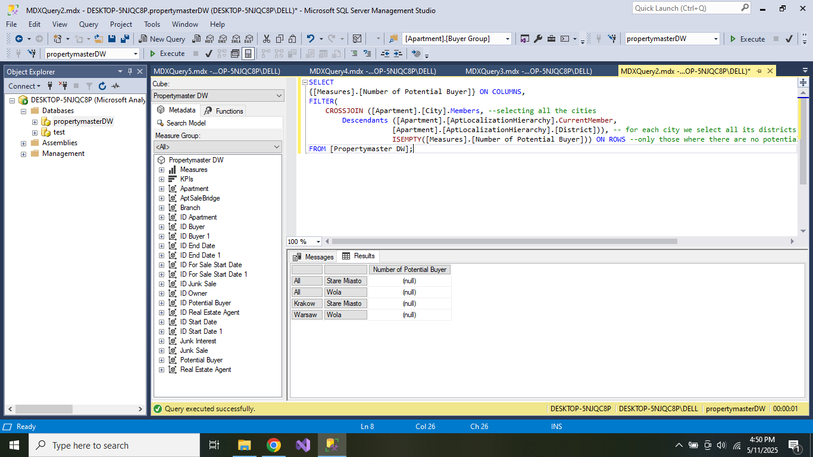
After:
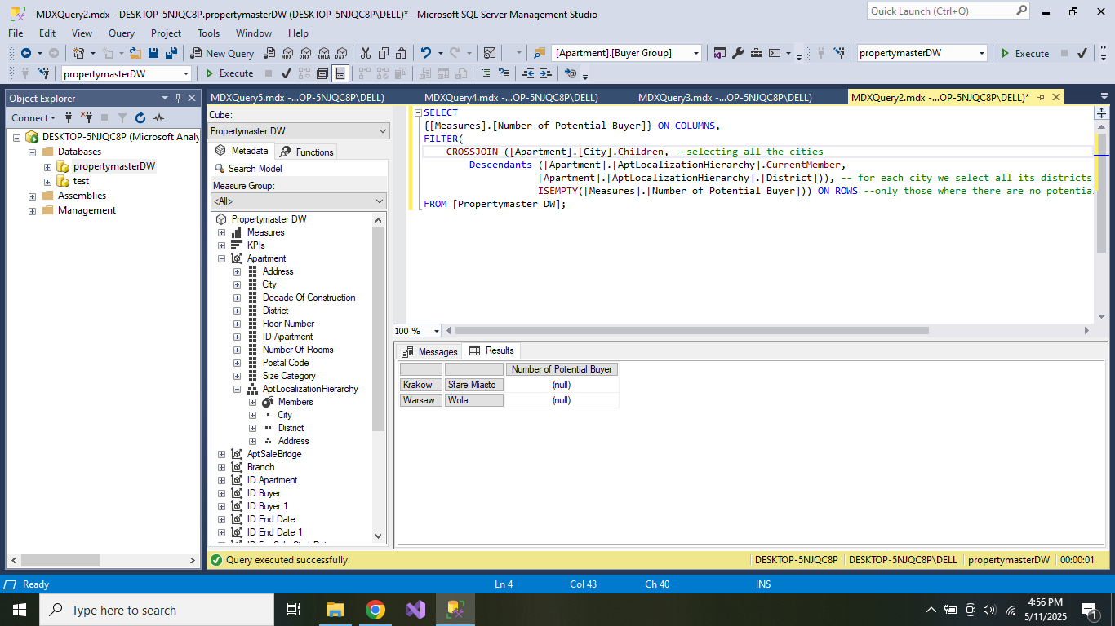

Query 7: everything was fine

Query 8: i guess this one looks fine, but because we dont track the exact date when the potential buyer reached out to buy the apartment i added to the query taht its with an assumption that the person reached out in the month the apartment went for sale yeah it looks fine but same as query 6 coz we can’t see exactly which year we are tracking
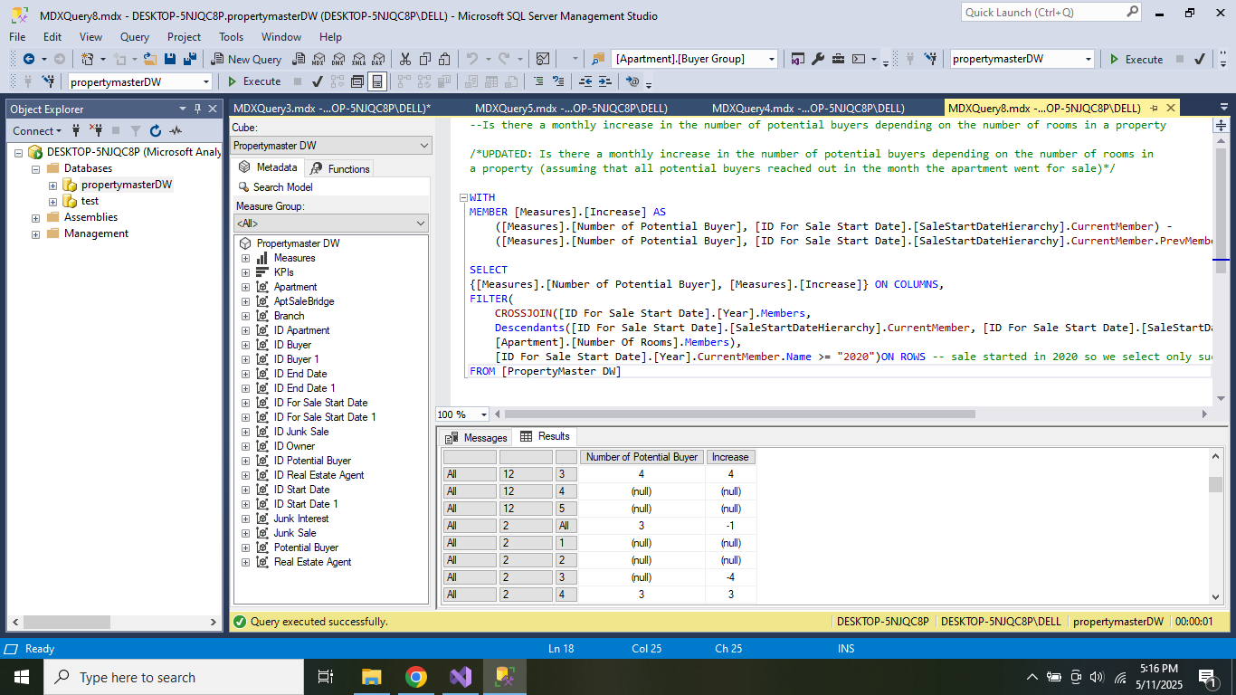
So maybe changing from members to children as well? I uploaded v2
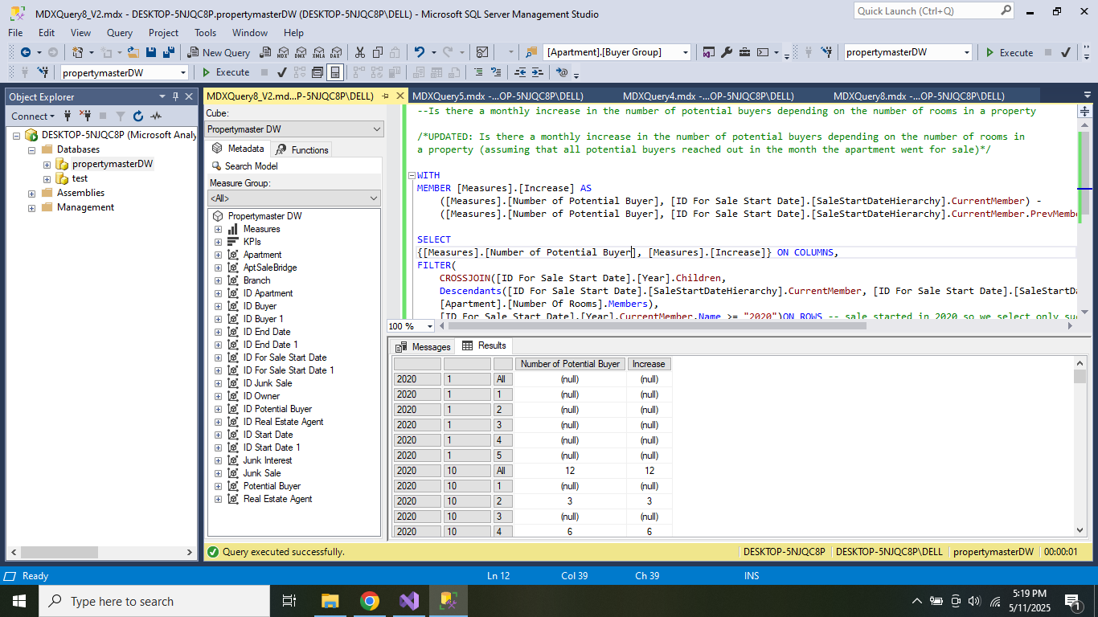

Query 9: so this query is basically redundant because for each branch we use exactly 5 districts and i didnt want to struggle with those districts - branch thing again so i changed it into top 5 decade of construction oh right well the updated query looks fine :) hmmmm sorry to say this again but i guess we can change members to children and use top 5 instead of top 6? See v2 pls.
Before:
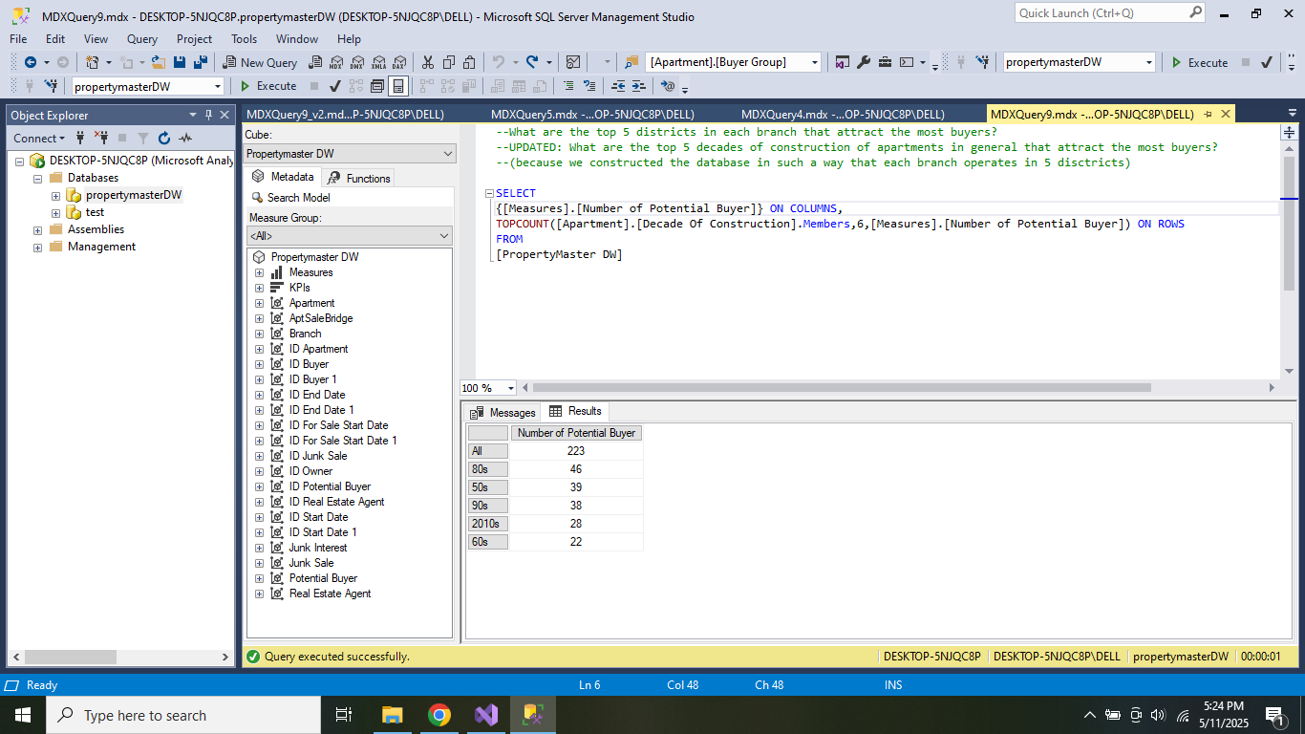
After:
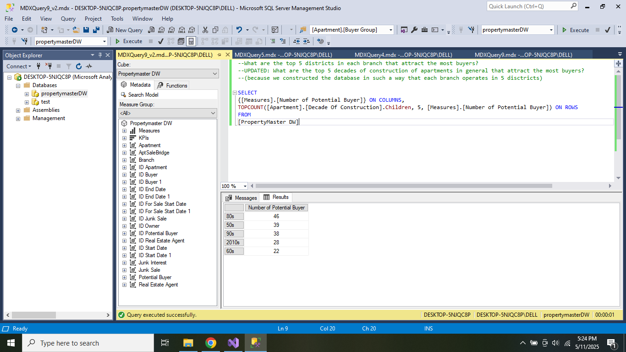

Query10: so right now i only performed the changed query from the new report without price ranges BUT i think the og query with those price ranges is doable but ill try to work on it later oh ok understood so i’m not checking this one

Query 2: i was inspired by query 6 that you wrote so i polished query 2 so that now we can see all districts in all cities not just one city (uploaded v2)
Before:
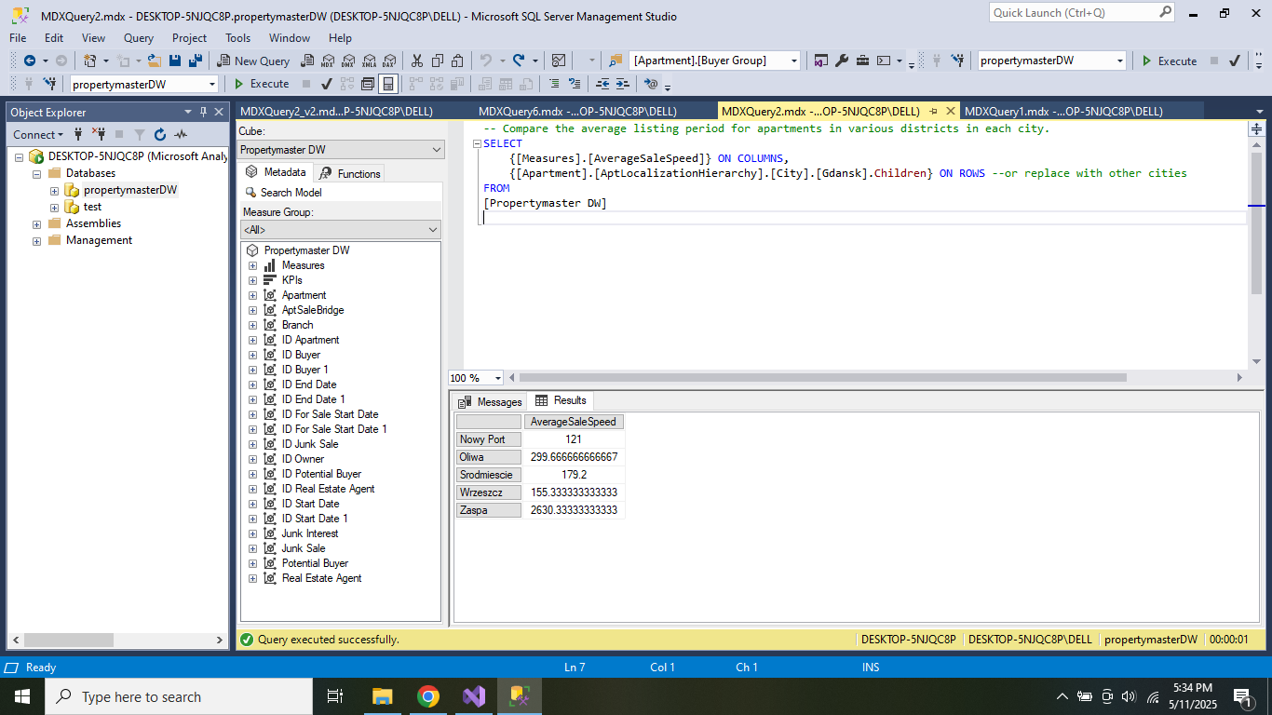
After:
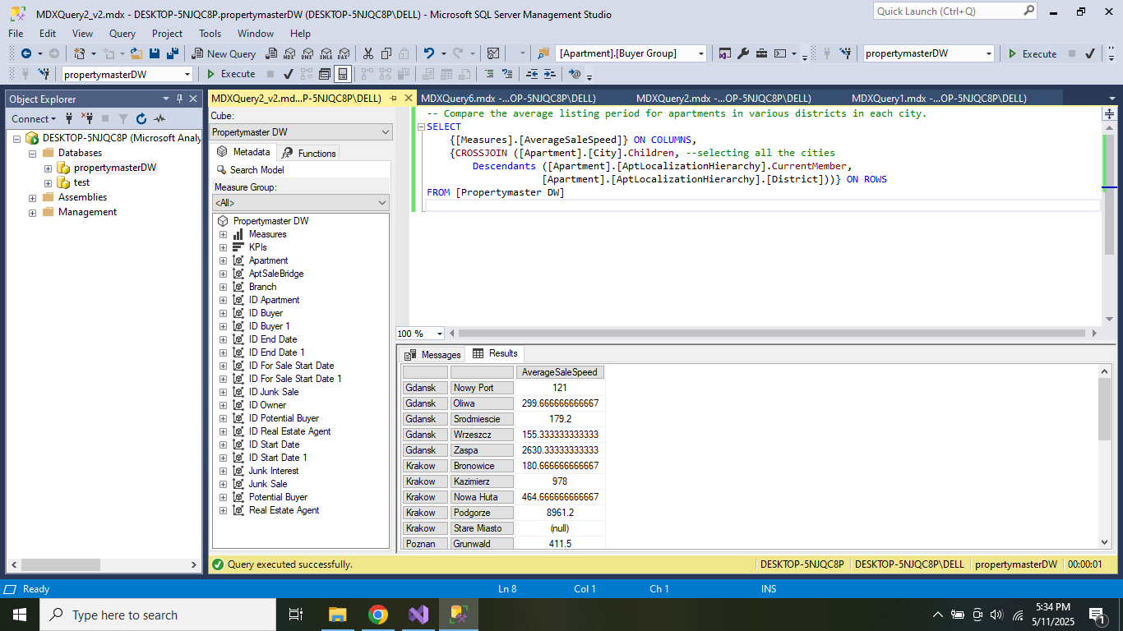

KPI

I did the first KPI definition and put all the expressions in the file KPIs & MDX Queries
Recommended steps: (there is an instruction file under task6 on eNauczanie)
- Prepare all the expressions and write them down in the file
- Open the cube and select KPI, in “KPI Organizer” right click and select “New KPI”
- Name the KPI and copy paste all the expressions
- Process the cube and go to browser
- In the top selection pane choose the correct dimension and hierarchy and “Equal” operator. In “Filter Expression” choose one year, drag the KPI and execute query and you should see the result similar to this:
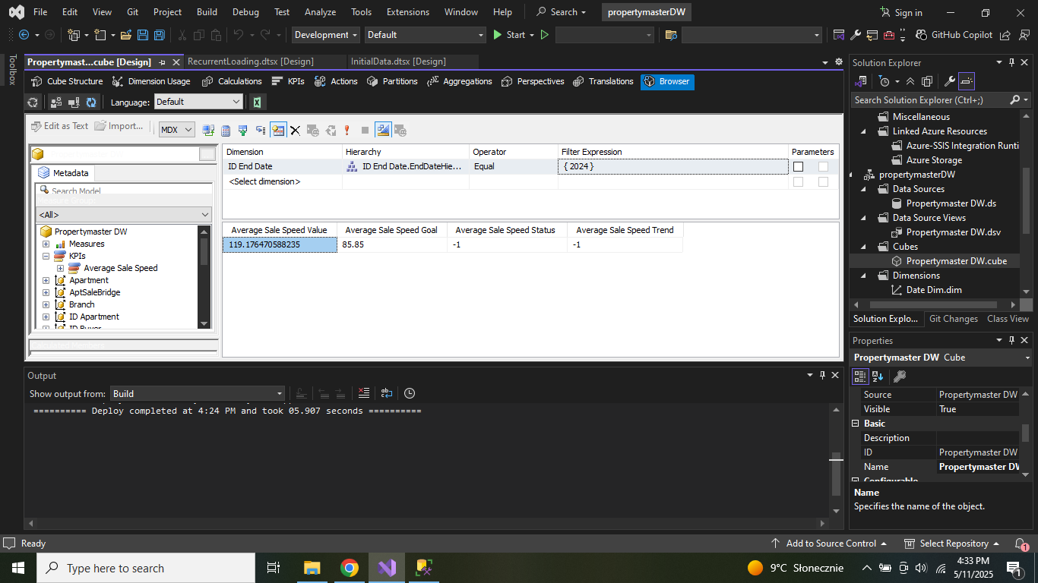

Hiiii, I have checked what you’ve done for KPIs and it looks good to me. I have created and added to the file the second KPI, so basically to add it you should just follow the same steps you have provided for me and in the top selection pane choose this : 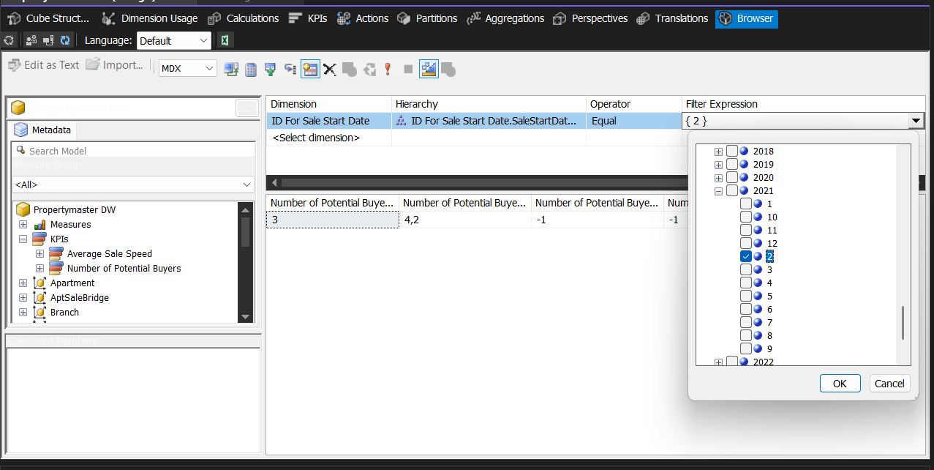

So remember to choose the month not year and to pick for sale start date (again here the problem is we dont really track when the person reached out to us so we assume its in the month the apartment went for sale)

Another thing is i copy pasted the queries into the file and modified how the queries are formed for 8-10. I tried to keep the color but what chatGPT told me didnt really work and i think its not necessary.

Another thing is i noticed that in query 7 also there is this All problem so i swapped member to children and its ok now and i swapped the file -> so query 7 is new kinda

And i tried to do query 10 in the old way but well…. It was actually pretty difficult so i just swapped price ranges to dirtricts and gave up, you can take a look and maybe try yourself but idk honestly

REQUIREMENTS:

Calculated member: 3, 4, 5, 8
WHERE clause: 1, 5
Dimension hierarchy: 2, 6, 8
top/bottom: 1, 9
Numerical operation: 3, 8

